Morehead State Bowling
Golf Scramble

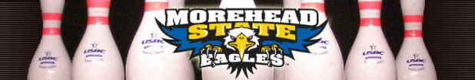
Morehead State University has a rich tradition of excellence in intercollegiate bowling and is respected as one of the premier bowling programs in the country. As a perennial bowling powerhouse, the Eagles are one of the most successful sports in Morehead State University history. The MSU women won national championships in 1989, 1998, 2000 and 2002, were runner-ups in 1993 and finished in third place in 2006 and 2008. The men’s squad was runner-up in its 2003 tournament and took third place in 2005.

GOLF TOURNAMENT APPLICATION
Saturday August 29th, 2015 @ Old Silo Golf Club Mount Sterling, KY
Check-in from 7:00 a.m. - 8:00 a.m. Shotgun Start at 8:00 a.m
Registration includes lunch, beverages, green fees and cart (Does not include driving range).
Cash prizes!!!! (Based on participation)

TOURNAMENT FORMAT:
Four-person captain choice scramble. Skirts and mulligans available for $5 each per person, or $20 for three mulligans and two skirts. Prizes will be given for longest drive and closest to pin.

Entry Fee Per Team $300
Entry Fee Per Person $75
Banner $300
Hole Sign $200
Putting Green Sign $150
Driving Range Sign $100

SIGNATURE LINE:

__________________________________________________________________

SPONSOR/COMPANY NAME:

________________________________________________________

CONTACT PERSON:

________________________________________________________________

PHONE NUMBER: _______________________E-MAIL: ______________________________

ADDRESS:

_________________________________________________________________________

Player Name / Handicap Address or E-Mail Phone Amount

1.__________________________________________________________________________
2.___________________________________________________________________________
3.___________________________________________________________________________
4.___________________________________________________________________________

Make checks payable to Eagle Classic.

Send Entry Form and Check to:

Bobby Brown
301 Bratton Loop
Morehead, KY 40351

Non Golfing Sponsorship:

- Banner
- Hole Sign
- Putting Green Sign
- Driving Range Sign

