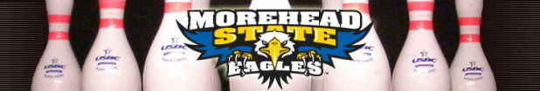
Hello from the Morehead State Bowling Team!
We are hosting a golf scramble on August 29th at the Old Silo golf course here in Mt. Sterling, Kentucky. We are looking for local companies that would like to become sponsors for each of the 18 holes of the tournament. We will be making signs for the companies that purchase a hole, which will be placed at the tee boxes and greens of the holes. The hole-signs are $200 a piece and you can write it off on your taxes. This is essentially free advertising for your business and you are helping a great cause.
Morehead State University has a rich tradition of excellence in intercollegiate bowling and is respected as one of the premier bowling programs in the country. As a perennial bowling powerhouse, the Eagles are one of the most successful sports in Morehead State University history. The MSU women won national championships in 1989, 1998, 2000 and 2002, were runner-ups in 1993 and finished in third place in 2006 and 2008. The men’s squad was runner-up in its 2003 tournament and took third place in 2005. We are considered a club sport through the university which means that we do not receive funding from them. We must fundraise all of our money to compete throughout the year and cover our travel expenses.
Purchasing a hole-sign would help us to fund our team for the upcoming season and also provide more publicity for your business. If you do not wish to purchase a hole-sign any donations that you would like to give would also be appreciated.
Thank you for your time,
Morehead State University Bowling Team

Below are the types of hole-signs that your company can purchase and their prices.
Banner $300
Hole-Sign $200
Putting Green Sign $150
Driving Range Sign $100

SIGNATURE LINE:

__________________________________________________________________

SPONSOR/COMPANY NAME:

________________________________________________________

CONTACT PERSON:

________________________________________________________________

PHONE NUMBER: _______________________E-MAIL: ______________________________

ADDRESS:

_________________________________________________________________________
Make checks payable to Eagle Classic.

Non Golfing Sponsorship:
- Banner
- Hole Sign
- Putting Green Sign
- Driving Range Sign

